Irish Society for Mucopolysaccharide Diseases

MPS 1 Hurler post HCST (BMT) Conference
in
Hilton Hotel, Kilmainham
on
Friday 11th March 2016
10.00am - 4.30pm

THIS CONFERENCE offers adults, parents, partners, carers and professionals the opportunity to hear state of the art talks on the clinical management of those affected by MPS 1 Hurler post Bone Marrow Transplant (BMT). As well as learning about the latest research developments.

CHILDREN AND VULNERABLE ADULTS: Under 18s will not admitted to the Conference and PLEASE NOTE There will be NO Child Minding facilities available at the Conference

There will be No Charge for this Conference

For more information on other MPS dieases please visit our website at www.irishmpssociety.ie and for news and events please visit our facebook page The Irish MPS Society - Facebook

We wish to thank Genzyme for kindly sponsoring our MPS 1 Hurler BMT Conference

Hurler Post BMT Conference 11th March 2015
Morning Session 10.30 – 13.00
10.00 | Registration & Teas, Coffees & pastries
 | Chair: Dr Ellen Crushell and Dr Anne O’ Meara
10.25 | Welcome Address Martin Lynch, Hon. Chairperson, Irish Society for Mucopolysaccharide Diseases
10.30-11.00 | Diagnosis + early ERT in Hurler Syndrome | Dr Simon Jones St Mary’s Hospital, Manchester, UK
11.00 – 11.30 | Manchester Experience with BMT for Hurler Syndrome | Dr Rob Wynn St Mary’s Hospital, Manchester, UK
11.30 – 12.10 | ERT Post BMT in Hurler Syndrome | Dr Paul Orchard Minnesota, USA
12.10 – 12.40 | Patient Perspective | Christine Lavery, Chief Executive UK MPS Society
12.40 | Questions and Answers
13.00 – 14.00 | Lunch
Hurler Post BMT Conference 11th March 2015
Afternoon Session 14.00 – 16.30
Chair: Dr Greg Pastores and Alison Wilson
14.00- 14.45 | Psychosocial development in Hurler Syndrome | Dr Elsa Shapiro Minnesota, USA
14.45-15.15 | Orthopaedic Complications | Ms Paula Kelly Our Lady’s Children’s Hospital, Crumlin, Dublin
15.15 – 15.30 | Eye Complications | Dr Donal Brasnahan, Our Lady’s Children’s Hospital, Crumlin, Dublin
15.30 – 15.45 | Respiratory Diesase including Obstructive Sleep Apnea in Hurler Syndrome | Dr Des Cox, Our Lady’s Children’s Hospital, Crumlin, Dublin
15.45 –16.00 | Dental care | Dr Eleanor McGovern Our Lady’s Children’s Hospital, Crumlin, Dublin
16.00 -16.30 | Clinical Trial of Atalauren in patients with MPS I | Dr Simon Jones
16.30 | Questions and Answers
16.45 | Close Teas & Coffees
Introducing the speakers

Mr Donal Brosnahan Consultant Ophthalmologist since 1999 in Our Lady’s Children’s Hospital, Crumlin, Royal Victoria Eye and Ear Hospital and Coombe Women and Infants University Hospital.

Dr Des Cox Consultant in Paediatric Respiratory Medicine in Our Lady’s Children’s Hospital, Crumlin since 2012.

Dr Simon Jones Consultant in Paediatric Inherited Metabolic Diseases at the Willink Biochemical Genetics Unit since 2008. He has been involved in many international multicentre trials for enzyme replacement therapy for lysosomal storage disorders.

Ms Paula Kelly Consultant Orthopaedic Surgeon in Our Lady’s Children’s Hospital, Crumlin, Tallaght Hospital and Coombe Women and Infants Hospital.

Ms Christine Lavery MBE Chief Executive of UK MPS Society since 1993 where she has grown this most successful charity which now supports nearly 1300 children and adult sufferers, their families and professionals in area of home adaptions, special educational needs, access to new therapies, respite care, palliative care and pre- and post-bereavement support. She is currently a patient representative on the NHS England LSD Specialised Commissioning Advisory Group.

Dr Eleanor McGovern Consultant Dental Surgeon in Our Lady’s Children’s Hospital, Crumlin and Temple Street Children’s University Hospital.

Prof Paul Orchard is the Medical Director of the Inherited Metabolic and Storage Disease Bone Marrow Transplantation Programme at the University of Minnesota Children’s Hospital. Prof Orchard has received many awards and some of his research interests are Transplant related toxicity and graft failure and Treatment of genetic and metabolic diseases with gene therapy.

Prof Elsa Shapiro Neuropsychologist, is Professor of Paediatrics and Neurology and the Director of the Paediatric Neuropsychology unit of the Division of Clinical Behavioural Neuroscience at the University of Minnesota. Prof Shapiro is known for research in neurobehavioural and neuroimaging manifestations of genetic neurodegenerative disorders. She developed methods of longitudinal assessment of neurocognitive functions, delineated the neurocognitive phenotypes of several genetic disorders, studied the relationship between quantitative neuroimaging and neuropsychology in treated and untreated children, and examined the characteristics of dementia in children with neurodegenerative disease. She is the co-Principal Investigator of the Lysosomal Disease Network and Principal Investigator of Longitudinal Studies of Brain Structure and Function in the Mucopolysaccharidoses. She is an editor of Child Neuropsychology and has approximately 70 peer reviewed publications and chapters.

Prof Rob Wynn Consultant Paediatric Haematologist & Director of Paediatric BMT Programme. He was appointed Consultant in Manchester in 1998 and has been Programme Director since 2004. He is the author of over 80 published papers, mostly in Paediatric Haematology and Transplant.

Booking Form for Hurler Post BMT Conference March 2016
Surname | Name | MPS  Y/N | Family | Professional | Wheelchair  User Y/N
Address:___________________________________________
___________________________________________________
___________________________________________________

Telephone:_______________ _ Fax: _______________

Email Address:______________________________________

Special Dietary needs (if any)___________________________
___________________________________________________

Deadline for Booking is 12th February 2016
Booking forms can be downloaded from www.mpssociety.ie and emailed to irishmpssociety@gmail.com or completed forms can be returned to
Mary McGauran, Glackbawn, Calry, Co Sligo
There will be No Charge for this Conference
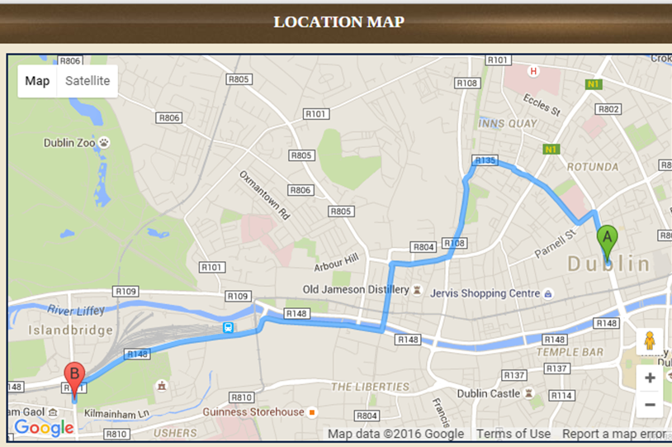
Directions to our Hotel Directions from the Airport to Hilton Dublin Kilmainham:
Follow signs for M1 motorway (signposted Dublin). Leave the M1 at junction 1 (Junction with M50), then at roundabout take the 3rd exit onto the M50 (signposted Other Routes, Southbound). Leave the M50 at junction 7, then merge onto Lucan Road - N4 (signposted City Centre). At traffic signals continue forward onto Lucan Road - N4. Continue forward onto Chapelizod Bypass - N4 Entering Dublin, passing the War Memorial Park on your left. At traffic signals continue forward onto Con Colbert Road - N4 (signposted City Centre) R111. At the next junction (Junction 63) stay in the right hand lane taking a right turn and then an immediate left turn onto South Circular Road - R111 (signposted N11, N81). You will see the Hilton on your immediate right. At first set of traffic signals turn right onto Inchicore Road (signposted Inchicore). Hilton Dublin Kilmainham is on your right.
From the West: Follow the M4 and N4 towards the city centre. Continue forward onto Chapelizod Bypass - N4 Entering Dublin, passing the War Memorial Park on your left. At traffic signals continue forward onto Con Colbert Road - N4 (signposted City Centre) R111. At the next junction (Junction 63) stay in the right hand lane taking a right turn and then an immediate left turn onto South Circular Road - R111 (signposted N11, N81). You will see the Hilton on your immediate right. At first set of traffic signals turn right onto Inchicore Road (signposted Inchicore). Hilton Dublin Kilmainham is on your right.

From City Centre: Start at Burgh Quay - N11 (signposted The West N4, N5, N6). At O'Connell Bridge, traffic signals continue forward onto Aston Quay - N4. At traffic signals continue forward onto Essex Quay - N4. At traffic signals continue forward onto Usher's Quay - N4 (signposted N4, N7, M50). At traffic signals continue forward onto Usher's Island - N4. Take left hand lane then at traffic signals (at Heuston Station) turn left onto Saint John's Road West - N4 (signposted The West, N7, M50). At Junction 63 branch left, then turn left onto South Circular Road - R111 (signposted N11, N81). You will see the Hilton on your immediate right. At first set of traffic signals turn right onto Inchicore Road (signposted Inchicore). Hilton Dublin Kilmainham is on your right.

Airport Directions: From Airport, follow signs to M50 and travel westbound to junction 7. Take exit 7 off the M50 and follow signs for City Centre. At Kilmainham roundabout go round almost doubling back and take left turn at junction. Hotel is on the right.

More information can be found at: www.hiltondublinkilmainham.com

